Entities and attributes
Entity | Attributes
Student | StudentID (PK), FirstName, LastName, Email, AdmissionDate
Program | ProgramID (PK), ProgramName, DegreeLevel, Department
Course | CourseID (PK), CourseCode, CourseTitle, Credits
ProgramEnrollment | ProgramEnrollmentID (PK), StudentID (FK), ProgramID (FK), StartDate, Status
CourseEnrollment | CourseEnrollmentID (PK), StudentID (FK), CourseID (FK), Term, Year, Grade

PK = Primary Key: uniquely identifies each record.
FK = Foreign Key: links a record to another table.

Relationships
Entities involved | Relationship type | Explanation
Student and ProgramEnrollment | One-to-many | One student can have many program enrollment records. Each record belongs to one student.
Program and ProgramEnrollment | One-to-many | One program can have many enrollment records. Each record refers to one program.
Student and CourseEnrollment | One-to-many | One student can have many course enrollment records. Each record belongs to one student.
Course and CourseEnrollment | One-to-many | One course can have many enrollment records. Each record refers to one course.
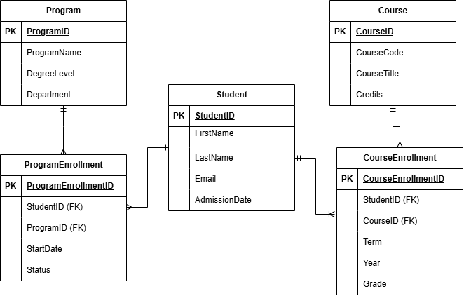
Relationships
One Student can have many ProgramEnrollment records, and one Program can have many ProgramEnrollment records. One Student can have many CourseEnrollment records, and one Course can have many CourseEnrollment records. ProgramEnrollment connects students and programs; CourseEnrollment connects students and courses. Each enrollment record belongs to exactly one student and one program or course. Grades in CourseEnrollment help track academic progress.

